**World Electrified Vehicle Sales (2013 Report)**

February 10th, 2014 by [Zach](http://evobsession.com/author/zshahan/)

[Republish Reprint](http://license.icopyright.net/rights/oneButtonTag.act?tag=3.15882?icx_id=2878" \t "_blank)

[**Republish Online**](http://license.icopyright.net/rights/republishOnlineServiceGroup.act?tag=3.15882?icx_id=2878)

[**Republish Offline**](http://license.icopyright.net/rights/republishOfflineServiceGroup.act?tag=3.15882?icx_id=2878)

[**Reprint**](http://license.icopyright.net/rights/reprintsServiceGroup.act?tag=3.15882?icx_id=2878)

[**Get Syndication Feed**](http://repubhub.icopyright.net/search.act?search=yes&showImmediate=yes&dateFilter=THIRTY_DAYS&featuredPublicationRestrictionString=p-15882&additionalPublication=15882)

First of all, let me note that these numbers below are not official and are surely a little imperfect (even more so than [US EV sales numbers](http://evobsession.com/electric-car-sales-increased-228-88-2013/)). However, they come from the most complete roundup of electrified vehicle (EV) sales I’ve seen. Frankly, I haven’t seen any other effort that tries to pull together EV sales in order to come to a global comparison.

The numbers again come from [Jose Pontes](http://www.ev-sales.blogspot.ch/2014/01/world-top-20-december-2013-special.html), as did the numbers for the [Europe electrified vehicle sales report](http://evobsession.com/europe-electrified-vehicle-sales-2013-report/) I just published. Check out the chart, the table, and my follow-up commentary:

[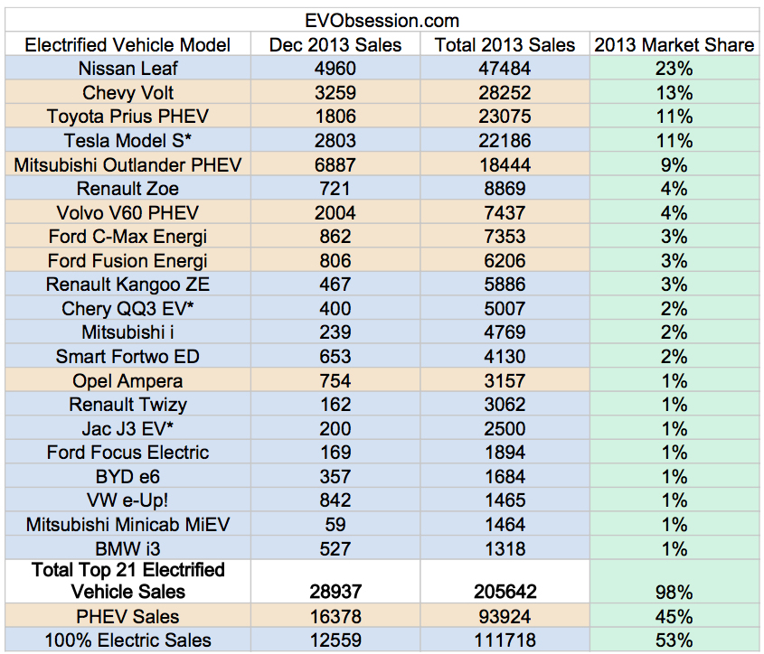](http://evobsession.com/world-electrified-vehicle-sales-2013/top-21-electric-vehicles-2013/)

Starting at the top, the [Nissan Leaf](http://evobsession.com/tag/nissan-leaf/) is the clear leader, with almost twice as many sales as the #2 [Chevy Volt](http://evobsession.com/tag/chevy-volt/). Though, given its rather limited availability outside the US, it’s impressive to see the Volt so high.

Building off of the success of the overall Prius brand, the [Toyota Prius PHEV](http://evobsession.com/tag/Toyota-Prius-PHEV/) comes in at #3, inches above the estimate of the high-demand, limited-supply [Tesla Model S](http://evobsession.com/tag/tesla-model-s/).

The [Mitsubishi Outlander PHEV](http://evobsession.com/tag/mitsubishi-outlander-phev/), after several months delay getting to market, stormed onto the scene at the end of 2013. [In its home country of Japan](http://evobsession.com/japan-electrified-vehicle-sales-2013-report/) (where it has been more available), it came it at #2 in 2013. Expect to see do quite well in 2014, and perhaps even rise above its #5 position. However, with the [BMW i3](http://evobsession.com/tag/bmw-i3/) and [VW e-Up!](http://evobsession.com/tag/vw-e-up/) just coming to market and starting off strong, expect to see them much higher on the list next year.

With strong sales in [Europe](http://evobsession.com/tag/europe/), the [Renault Zoe](http://evobsession.com/tag/renault-zoe/) and [Volvo V60 PHEV](http://evobsession.com/tag/volvo-v60-phev/) come in at #6 and #7, while the US-focused [Ford C-Max Energi](http://evobsession.com/tag/ford-c-max-energi/) and [Ford Fusion Energi](http://evobsession.com/tag/ford-fusion-energi/) follow close behind at #8 and #9. Ford and Renault, whose [Renault Kangoo ZE](http://evobsession.com/tag/renault-kangoo-ze/) van comes in at #10, are the only companies that crack the top 10 with two vehicles.

Notably, Renault and Nissan also [just announced](http://www.nissan-global.com/EN/NEWS/2014/_STORY/140207-01-e.html) on Friday that the Renault–Nissan Alliance dominates zero-emission vehicle sales. “The Alliance’s worldwide zero-emission market share in 2013 stood at 63%.” That’s impressive. Though, there will be much more competition this year.

As you can tell from the chart, the large majority of electrified vehicle sales came from the top 5 models in 2013, representing 67% of all electrified vehicle sales. I think we’ll see big sales spread further down the list in 2014.

One of the fun things about being in the very early stages of an electrified vehicle revolution is that these rankings can change very fast. Nonetheless, I think it’s a safe bet to say that the Nissan Leaf will be #1 again in 2014, perhaps followed by the Tesla Model S as Tesla is able to further ramp up its production. Aside from those two, however, there are a handful of competitive EVs now on the market that will be vying for a spot in the top 5 — the Mitsubishi Outlander PHEV, the BMW i3, the VW e-up!, the [VW e-Golf](http://evobsession.com/tag/vw-e-golf/) (if Volkswagen really tries to sell it), the Toyota Prius PHEV, the Chevy Volt, the Ford Energi PHEVs, the Volvo V60 PHEV, the Renault Zoe, the [BYD Qin PHEV](http://planetsave.com/2014/01/29/byd-officially-launches-qin-phev-china/) (a hot new car sure to dominate [the Chinese EV market](http://evobsession.com/china-electric-car-sales-leaders-2013/)), and perhaps even the [Mitsubishi i](http://evobsession.com/tag/mitsubishi-i/) if the massive price drop announced for the 2014 model comes with wider availability and strong consumer interest. We’ll see. Any guesses for the top 5 or top 10?